CBIO310: Data analysis and visualization

Dr.Mohamed El Sayeh

Unraveling the Genetic and Pathway Overlap Between SARS-CoV-2 and Alzheimer’s Disease: Insights for Future Therapeutic Strategies

Name | IDs
Dana Mohamed Zekry | 221000946
Malak Ibrahim | 211001266

Table of Contents
- Abstract 2
- Introduction 3
- Methods 4
  - Data Collection and Preprocessing 4
  - Identification of Common Genes and shinyGo analysis 5
  - Pathway Analysis 5
  - Statistical and Bioinformatics Validation 5
- Results 6
  - Insights Plots for COVID-19 and Alzheimer’s Disease 6
  - R analysis and common genes function 11
  - ShinyGo analysis 13
- Discussion 25
  - Genetic Intersection and Implications 25
  - Pathway Enrichment Insights 26
  - Therapeutic Implications 26
  - Future Research Directions 27
- Conclusion 27
- References 29

Abstract
Alzheimer's disease (AD) and SARS-CoV-2 (COVID-19) are two major worldwide health issues that are marked by high rates of morbidity and mortality. There is growing evidence that viral infections and neurodegenerative diseases share processes, especially through vascular, immunological, and inflammatory pathways. To identify common genetic and route crossovers between SARS-CoV-2 and AD, this work uses a thorough bioinformatics method. Common genetic markers were found by analyzing differentially expressed genes (DEGs) from publicly accessible transcriptome datasets. For functional annotation and pathway enrichment, programs like R, ShinyGO, and the Kyoto Encyclopedia of Genes and Genomes (KEGG) were used. C3, C2, ND5, F5, F12, and F8 are six important genes were found to be involved in complement and coagulation cascades, mitochondrial dysfunction, and immunological responses . Enrichment studies emphasized the significance of inflammation, immunological dysregulation, and mitochondrial dysfunction as common causes, highlighting pathways such the complement system, coronavirus disease (COVID- 19), and neurodegenerative disease pathways. These results imply that SARS-CoV-2 infection may worsen AD pathogenesis through these interrelated mechanisms.
This work suggests possible therapeutic targets for dual intervention and offers important insights into the molecular interactions between viral infections and neurodegenerative disorders. To turn these findings into practical measures to address the combined burden of COVID-19 and Alzheimer's disease, more clinical research and experimental validation are necessary.

Introduction
SARS-CoV-2 (severe acute respiratory syndrome-Corona Virus Disease 2019) emerged as a serious global health emergency with the greatest incidence rates recorded globally.
According to the World Health Organization (WHO), the COVID-19 epidemic killed almost
6.8 million individuals and infected over 600 million people as of March 6, 2023. By this point, 1.3 billion doses of the COVID-19 vaccine had been distributed, which helped to successfully contain the pandemic and significantly lower the number of fatalities and serious illnesses [1,2]. The virus only binds to ACE2, a crucial receptor, and causes acute respiratory distress. The genome of SARS-CoV-2 is made up of 29,811 nucleotides of positive-stranded ssRNA. The brain, bone marrow, spleen, blood, blood vessels, and muscle have lower levels of ACE2 expression than do the small intestine, testis, heart, kidneys, and thyroid. With research showing the presence of viral RNA transcripts and proteins in the brain tissues of COVID-19 patients during autopsy, the virus's capacity to impact neurological health is becoming more widely acknowledged. Recovered COVID-19 individuals have shown neurological symptoms, including as memory loss and cognitive impairment, raising fears that the virus may hasten the onset of neurodegenerative disorders like Parkinson's and Alzheimer's diseases [5,6]. The mechanisms that cause COVID-19-associated brain damage involve infection directly of the brain and nervous system (CNS), systemic hyperinflammatory replies, outside organ failure, grave coagulopathy, cerebrovascular ischemia occurred, and forced ventilation during serious illnesses.

Over 50 million individuals worldwide suffer from Alzheimer's Disease (AD), a major neurological illness, and estimates indicate that by 2050, that number may rise to 150 million [2]. The breakdown of amyloid precursor protein (APP) in the brain, which results in the buildup of beta-amyloid (Aβ) plaques in the extracellular space, is the primary pathogenic characteristic of AD. Alpha-, beta-, and gamma-secretases are the three main

secretase enzymes that mediate the cleavage process of APP. The hyperphosphorylation of tau proteins, which destabilize microtubules and disrupt synaptic function, is another characteristic of AD that leads to neurodegeneration. Furthermore, infections can enter the brain due to an increased blood-brain barrier (BBB) permeability, which may accelerate the onset of AD. Viral infections, such as SARS-CoV-2, are specifically linked to the onset and advancement of AD because they may penetrate the blood-brain barrier and cause inflammatory reactions in microvascular endothelial cells, which leads to BBB failure[2,3].

In light of this, our study will concentrate on determining the genetic elements that are shared by Alzheimer's disease and SARS-CoV-2 infection, as well as clarifying the shared pathways that underlie the etiology of both conditions . We want to identify the common molecular pathways and genetic targets that might be used as therapeutic targets for both COVID-19 and neurodegenerative illnesses by utilizing integrated bioinformatics and systems biology techniques. A thorough grasp of the biological complexity underlying these multifactorial diseases influenced by both viral infection and neurodegeneration will be possible thanks to this comparative analysis of common genes and pathways, which will also yield important insights for future research and therapeutic development.

Research Questions
- What genes are commonly dysregulated between SARS-CoV-2 infection and Alzheimer’s disease based on transcriptomic data?
- Which biological pathways are shared between SARS-CoV-2 and neurodegenerative disease mechanisms?
- How do immune response, coagulation, and mitochondrial dysfunction contribute to the overlap between viral infection and neurodegeneration?
Objectives
- To identify differentially expressed genes (DEGs) in SARS-CoV-2 and Alzheimer’s disease using publicly available transcriptomic datasets.
- To determine common genes shared between both conditions using bioinformatics and statistical analysis.
- To perform functional annotation and pathway enrichment analysis using KEGG and ShinyGO.
- To investigate immune, coagulation, and mitochondrial pathways linking viral infection to neurodegenerative disease.
- To explore the broader relevance of identified genes to other neurodegenerative disorders.

Methods

Data Collection and Preprocessing
Datasets were obtained from the Gene Expression Omnibus (GEO) database in order to perform the RNA-seq study. Two distinct studies were chosen, one on Alzheimer's disease (AD) and the other on SARS-CoV-2 (COVID-19). To guarantee consistency and comparability, ten control samples and ten illness samples were chosen for each dataset. For both datasets, differential expression analysis (DEA) and experimental group definition were carried out using GEO2R, an online program made available by GEO. The differentially expressed genes (DEGs) for every illness were obtained from the GEO2R data.

Identification of Common Genes and shinyGo analysis
Statistical computing environment R was used to evaluate the DEGs from both disorders. To find shared genes between the SARS-CoV-2 and Alzheimer's disease datasets, a specially written R script was utilized. In order to identify common genes that could have overlapping roles in the pathophysiology of both illnesses, the two DEG lists were intersected. We used ShinyGO, a complete bioinformatics tool for functional annotation, to learn more about the functions of the common genes. ShinyGO was utilized for enrichment analysis, phylogenetic tree construction, and gene function exploration. While phylogenetic analysis evaluated evolutionary links, functional annotation concentrated on identifying the biological roles and processes in which these genes are engaged.

Pathway Analysis
The pathways connected to the discovered common genes were found using the Kyoto Encyclopedia of Genes and Genomes (KEGG) database. A thorough understanding of the molecular pathways that could be involved in the interaction between SARS-CoV-2 and Alzheimer's disease was made possible by KEGG enrichment analysis. Through this research, we were able to identify pathways that significantly included common genes, providing insight into possible mechanistic connections between neurodegeneration and viral infection.

Statistical and Bioinformatics Validation
The analyses carried out in GEO2R, R, ShinyGO, and KEGG underwent thorough validation to guarantee correctness and repeatability, To make sure the DEGs and pathway linkages were reliable, statistical criteria like adjusted p-values and false discovery rates (FDR) were used. In order to thoroughly investigate the genetic and molecular connections between SARS-CoV-2 and Alzheimer's disease, our methodical methodology included RNA-seq analysis, functional annotation, and pathway enrichment.

Results

Insights Plots for COVID-19 and Alzheimer’s Disease

A B

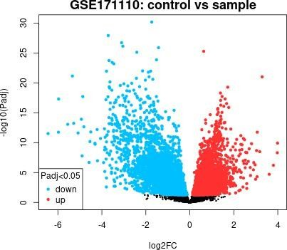
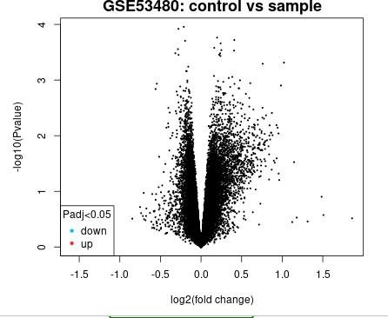

Figure 1: Volcano plots showing the distribution of differentially expressed genes (DEGs) for COVID-19 and Alzheimer's disease are shown in the 2 figures. In figure A shows that Important upregulated genes are shown in red in these plots, downregulated genes are shown in blue, and non-significant genes are shown in gray. In figure B shows that the upregulated genes in right area and downregulated in left area. The y-axis shows the - log10(p-value), which indicates statistical significance, and the x-axis shows the log2 fold change. Genes that are deemed substantially differentially expressed are those that exceed the adjusted p-value criteria (Padj < 0.05). The Alzheimer's Disease dataset (GSE53480) shows expression data from Tg4510 and wild-type mice, whereas the SARS- CoV-2 dataset (GSE171110) shows whole blood transcriptome analysis in severe COVID-19 cases compared to controls. These plots provide insights into disease-specific transcriptional alterations by acting as a first visual representation of the major genes that are affected in each condition.

A B

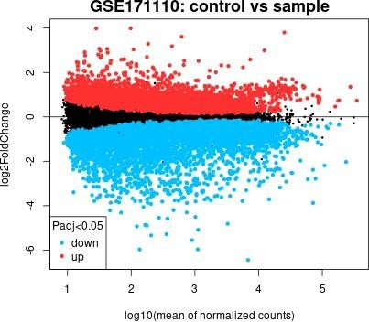
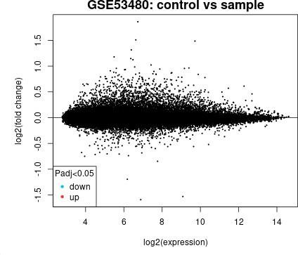

Figure 2: The transcriptome analysis findings for two datasets, GSE171110 and GSE53480, are displayed using mean difference plots, commonly referred to as Bland-Altman plots. In figure A shows that GSE53480 dataset focuses on Alzheimer's disease and contains expression data from Tg4510 and wild-type mice. In figure B shows that GSE171110 dataset shows whole blood transcriptome analysis in severe COVID-19 patients compared to controls. The y-axis in these graphs displays the mean difference in expression (log2 fold change) for each gene, while the x-axis depicts the average level of gene expression between the control and sample groups. In order to highlight the important transcripts that changed between the groups, genes with statistically significant differential expression (Padj < 0.05) are highlighted. These plots help identify genes with consistent and physiologically significant variations across environments by offering a thorough picture of gene expression variability.

A B
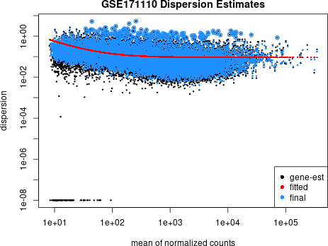
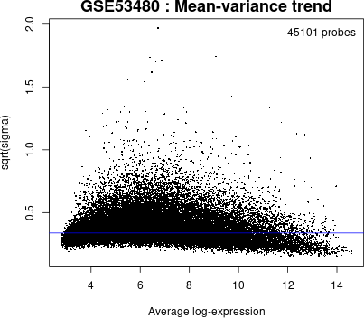

Figure 3: In RNA-seq and microarray data processing, a mean-variance plot between the mean expression levels of genes and their variability (variance) among samples. Genes with lower means generally show little or no expression, whereas those with higher means are actively transcribed. The x-axis shows the mean expression levels, which are determined by averaging normalized counts or expression values. Variability or variations in gene expression among samples are measured by the y-axis. Low variance denotes constant expression, while high variance genes exhibit notable variations in expression across samples.

A B
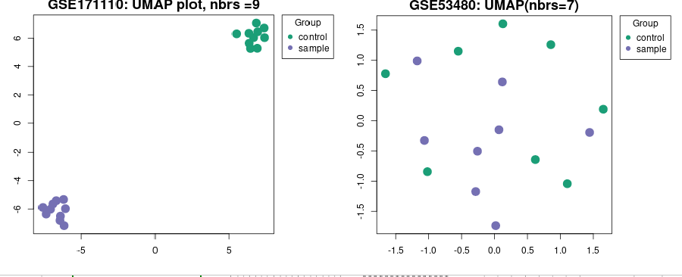

Figure 4: The control samples in this UMAP images are represented by green dots, which usually group together to show comparable gene expression patterns indicative of a healthy condition. Disease samples are represented by purple dots, which may indicate clusters of gene expression patterns specific to the illness being studied. Critical information may be gleaned from the spatial organization of the green and purple clusters: overlap denotes common characteristics or transitional phases, whereas apparent separation reveals major transcriptional differences between the control and illness groups. Understanding group differences and verifying experimental classifications are made easier by this graphical depiction, which offers a thorough picture of the dataset's structure. The two main dimensions obtained from the high-dimensional dataset are represented by the x-axis and y-axis. These axes offer a geographic depiction of the similarity rather than corresponding to biological factors. The distance between points indicates similarity or dissimilarity in their gene expression profiles. Clusters of points reflect groups of samples that share similar expression patterns.

A B
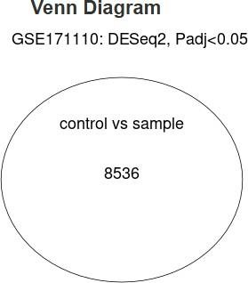
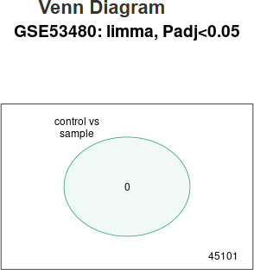

Figure 5: The correlations and overlaps between datasets, such as differentially expressed genes (DEGs) from different situations, can be visually represented with a Venn diagram. With overlapping sections signifying shared genes and non-overlapping areas signifying

unique elements unique to each dataset, each circle in the graphic represents a different dataset.

A B
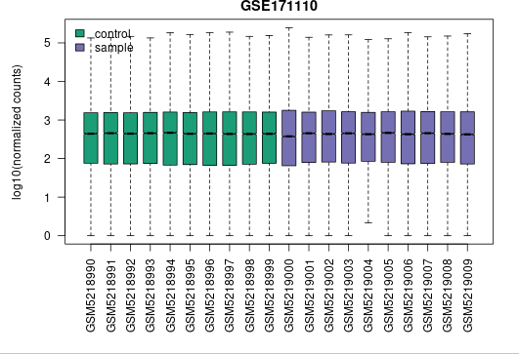
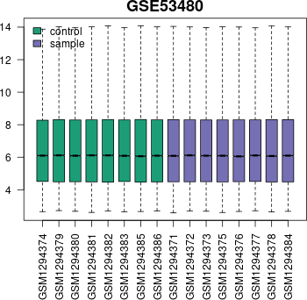

Figure 6: The Box plot for each dataset provides insights into the data's central tendency, variability, and potential outliers.

A B
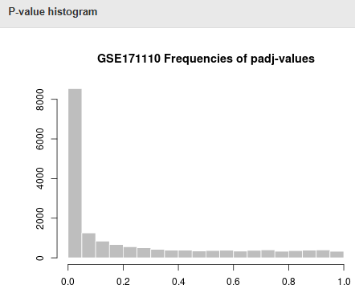
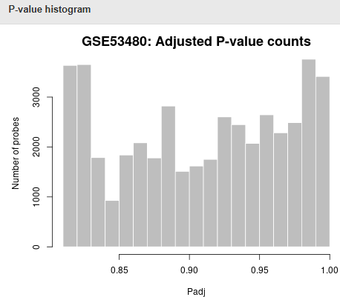

Figure 7: These figures show p-values from statistical tests are distributed throughout a dataset. x-axis shows the range of p-values. The frequency or count of p-values inside each bin is shown on the y-axis.

R analysis and common genes function
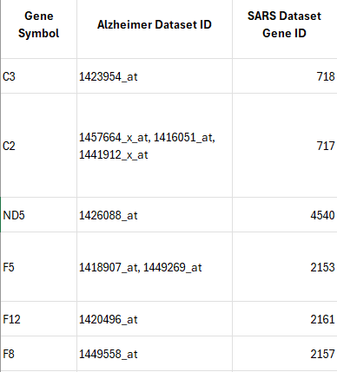
The R analysis's findings revealed the genes that the two illnesses had in common, pointing to possible genetic overlaps and biochemical pathways that might be involved in their etiology.

Figure 8: the common gene between 2 DEGs Table 1: these are the common genes between 2 diseases and their functions.
Gene name | Function in SARs | Function in Alzheimer
C3 (Complement Component 3) | In the inflammatory response to SARS-CoV-2 infection, C3 is essential. Its activation has a role in the hyperinflammatory condition, which includes lung tissue destruction and cytokine release syndrome, that is observed in severe  COVID-19 patients. | A key element of the complement system that plays a role in the immunological response is C3. One of the characteristics of AD is neuroinflammation, which it exacerbates. In the brain, excessive C3 activation can  result in

 |  | neurodegeneration, plaque development, and synapse loss.
C2 (Complement Component 2) | C2 enhances inflammation and vascular injury in COVID-19 by aiding in complement activation.  Endothelial dysfunction and coagulopathy may result from its involvement in the complement cascade. | The conventional complement route includes C2. Although excessive activation might worsen neuronal damage, its role in AD is linked to increasing neuroinflammation and amyloid-beta clearance.
ND5 (NADH Dehydrogenase Subunit 5) | ND5 dysregulation may exacerbate tissue damage and systemic inflammation in COVID-19 by causing altered mitochondrial dynamics, elevated oxidative stress, and poor energy metabolism. | A component of complex I in the electron transport chain is encoded by the mitochondrial gene ND5. In AD, ND5 dysfunctions result in compromised mitochondrial activity, which exacerbates oxidative stress and damages neurons.
F5 (Coagulation Factor V) | The prothrombotic condition seen in severe COVID-19 patients is influenced by F5. It  contributes to the | The cascade of blood coagulation involves F5. A higher risk of microvascular injury and  neuroinflammation is

 | production of clots and is linked to the emergence of thromboembolic consequences. | associated with vascular dysfunction and altered coagulation mechanisms in AD.
F12 (Coagulation Factor XII) | The hypercoagulable condition associated with COVID-19 is linked to F12 activation, which also causes inflammation, endothelial damage, and excessive clot formation. | The intrinsic coagulation pathway is initiated in part by F12. The pathophysiology of AD may be exacerbated by dysregulated F12 activity, which may also lead to inflammation and vascular dysfunction.
F8 (Coagulation Factor VIII) | F8 plays a crucial part in clotting irregularities that, in extreme situations, might result in thrombosis and related problems, contributing to coagulopathy in COVID-19. | The blood coagulation pathway involves F8. Increased risk of cerebrovascular illness and vascular dysfunction have been linked to elevated F8 levels, which can worsen the course of AD.

ShinyGo analysis

A



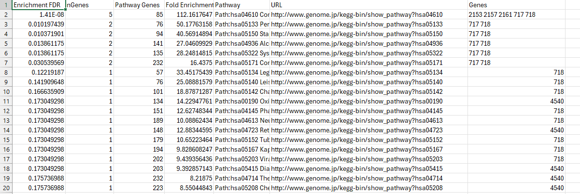

B
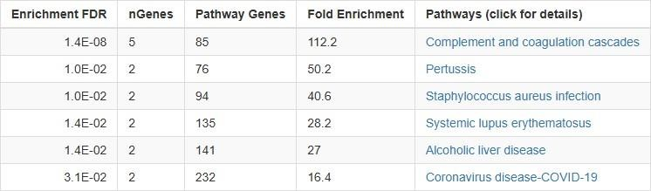

C

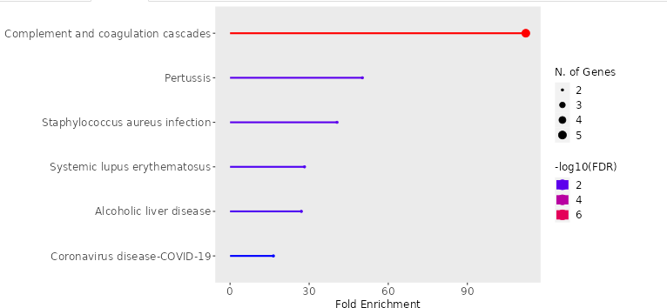

D

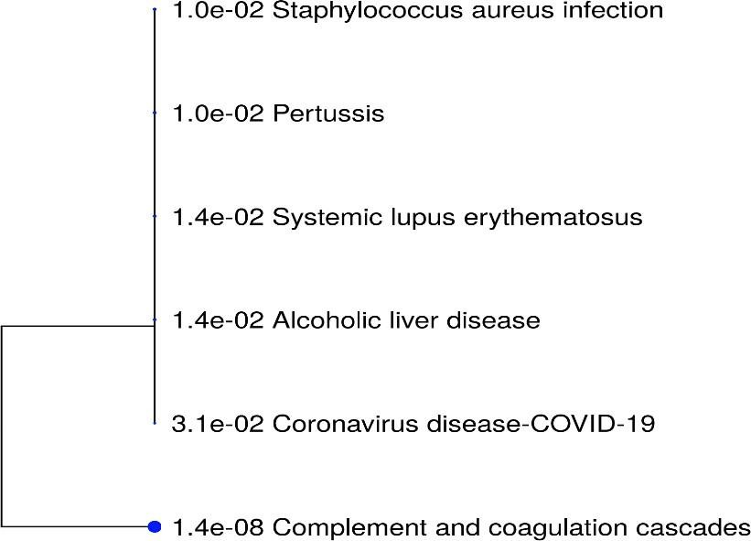

F

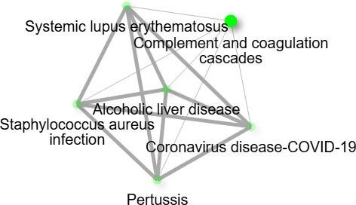

G

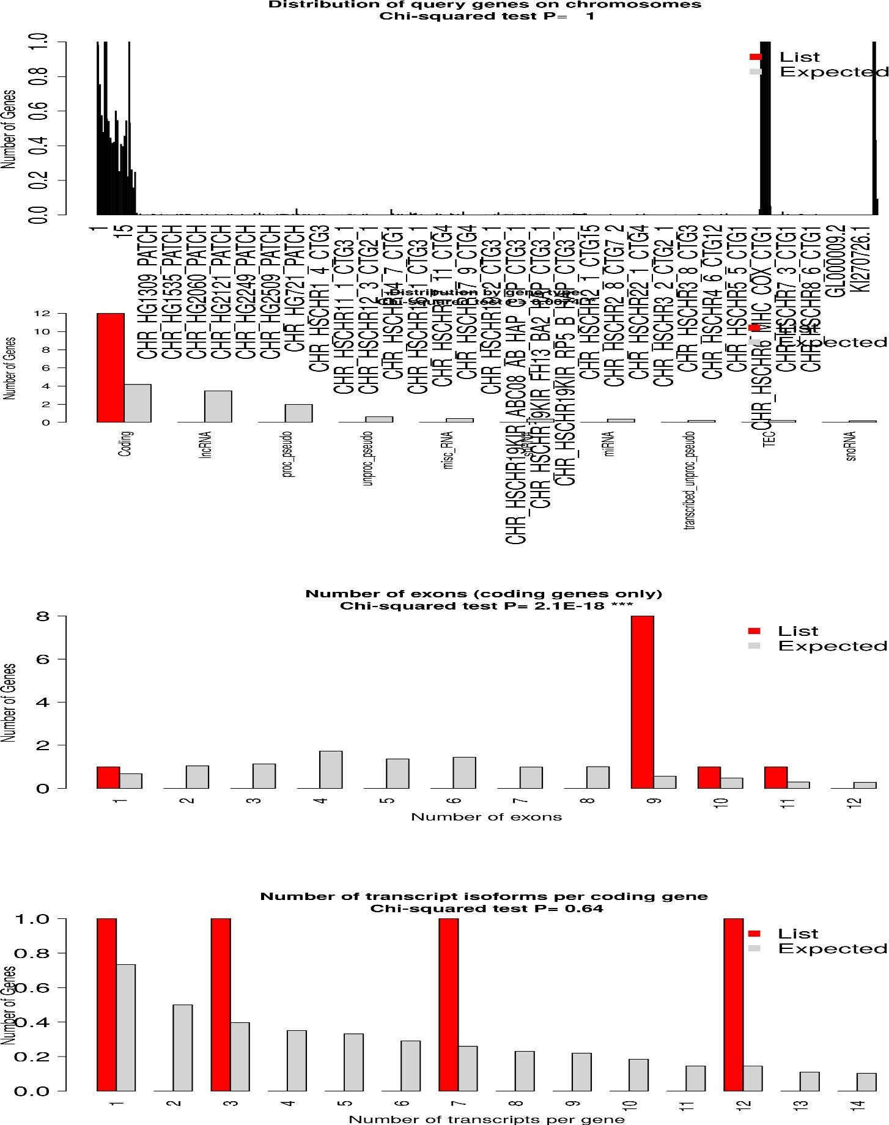

Figure 9: targeted gene set's enrichment analysis indicates a strong participation in pathways linked to inflammation, immunological responses, and mitochondrial dysfunction—all of which are closely associated with neurodegenerative illnesses including Parkinson's and Alzheimer's. Important elements in your dataset, such as C3 and C2, are essential for the complement and coagulation cascades, which are essential for inflammation and immunological activation. These complement proteins may have a role in neuroinflammation, a defining feature of Alzheimer's disease, as they are closely linked to autoimmune and inflammatory disorders. Furthermore, mitochondrial dysfunction—a key component of neurodegeneration—is linked to ND5, a gene involved in energy production and mitochondrial function. Given that mitochondrial dysfunction is frequently seen in neurodegenerative illnesses, this emphasizes the link between mitochondrial impairment and these conditions. Blood clotting-related coagulation factors F5, F12, and F8 may also be important in neurovascular diseases associated with Alzheimer's and other neurodegenerative diseases. The biological importance of these genes in the discovered pathways is supported by low values (<0.05) of the False Discovery Rate (FDR), which show substantial statistical significance in the pathways. This is further supported by the fold enrichment values, which indicate that your gene set's overrepresentation in these pathways indicates its significance in inflammation, the immunological response, and mitochondrial dysfunction. All things considered, the research points to the importance of these processes in comprehending how these genes work in neurodegenerative disorders, where inflammation, immunological dysregulation, and mitochondrial dysfunction are critical elements.

Table 2: Genetic Insights into Coagulation, Immune Response, and Mitochondrial Dysfunction in Neurodegenerative Diseases

Paste  d | Symb  ol | Ensembl Gene  ID | Entre  z | Type | Specie  s | Positio  n (Mbp) | Description
2153 | F5 | ENSG000001987  34 | 2153 | codin  g | Huma  n | 169.512  0 | coagulation  factor V
2161 | F12 | ENSG000001311  87 | 2161 | codin  g | Huma  n | 177.402  1 | coagulation  factor XII
717 | C2 | ENSG000001662  78 | 717 | codin  g | Huma  n | 31.8978 | complement  C2
718 | C3 | ENSG000001257 30 | 718 | codin g | Huma n | 6.6777 | complement C3
4540 | MT- ND5 | ENSG000001987 86 | 4540 | codin g | Huma n | 0.0123 | mitochondrially encoded NADH:ubiquino ne oxidoreductase  core subunit 5
717 | C2 | ENSG000002315  43 | 717 | codin  g | Huma  n | 31.8800 | complement  C2
2157 | F8 | ENSG000001850  10 | 2157 | codin  g | Huma  n | 154.835  8 | coagulation  factor VIII

As shown in table 2 that the dataset involves multiple human genes associated with immune responses, coagulation, and mitochondrial function, which are of particular significance when considering their roles in neurodegenerative diseases. Blood clotting is regulated by the F5 gene (coagulation factor V), which is found on chromosome 1 at location 169.512 Mbp. The coagulation cascade, which is necessary for controlling bleeding and inflammation, is also significantly influenced by **F12** (coagulation factor XII), which is found on chromosome 5 at location 177.402 Mbp. Both genes are linked to neurovascular disorders where dysregulated coagulation may play a role in etiology, such

as Alzheimer's disease. Complement component 2, an essential protein in the immune response and a component of the classical complement system, is encoded by the C2 gene, which is found on chromosome 6 at location 31.897 Mbp. The C2 gene's significant function in immune regulation is further highlighted by the description of many isoforms of the gene in various chromosome 6 locations. Complement component 3, another essential component of the complement system that plays a role in inflammation and immunological defense, is encoded by C3, which is found on chromosome 19 at location 6.6777 Mbp. Immune activation requires both C2 and C3, and its dysregulation is linked to inflammation and autoimmune disorders, two major contributors to neurodegeneration. Furthermore, NADH ubiquinone oxidoreductase core subunit 5, a crucial part of the mitochondrial respiratory chain, is encoded by MT-ND5, which is found on the mitochondrial genome. Because of its connection to energy generation through mitochondrial function, this gene's malfunction has been linked to neurodegenerative illnesses including Parkinson's and Alzheimer's, where cell death is a result of mitochondrial impairment. Finally, hemophilia and blood clotting are influenced by **F8** (coagulation factor VIII), which is found on the X chromosome at location 154.8358 Mbp. This gene's inclusion in your analysis raises the possibility of a connection between coagulation and neurovascular issues, which might have an impact on diseases like Alzheimer's, where vascular pathology is frequently seen. All things considered, these genes—F5, F12, C2, C3, MT-ND5, and F8—are essential for immunological response, coagulation, and mitochondrial function.

  - KEGG pathways analysis

Hsa04C10 Complement and coagulation cascades pathway
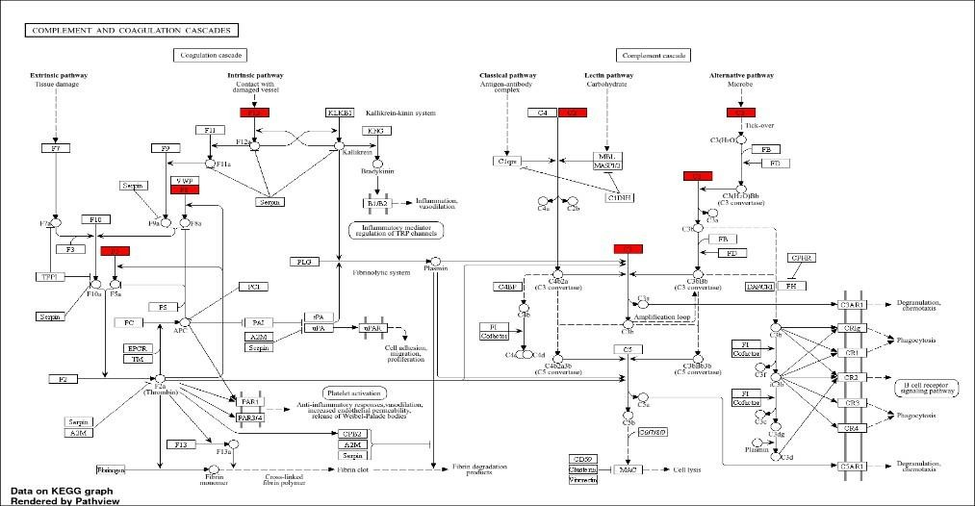

Hsa05322 Systemic lupus erythematosus Alcoholic liver disease
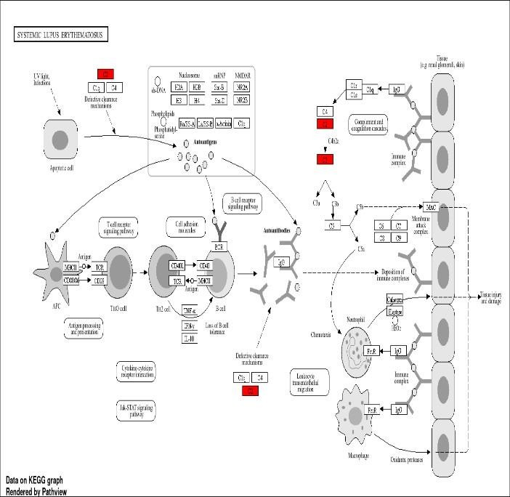
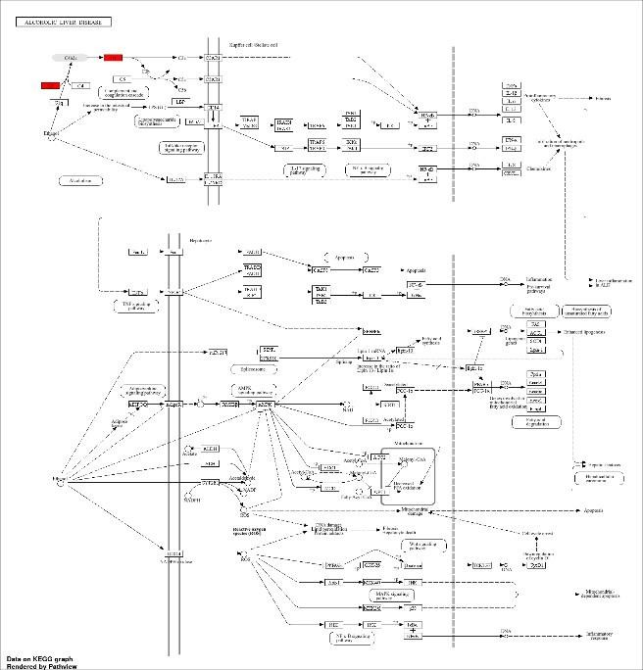

Hsa05150 Staphylococcus aureus infection
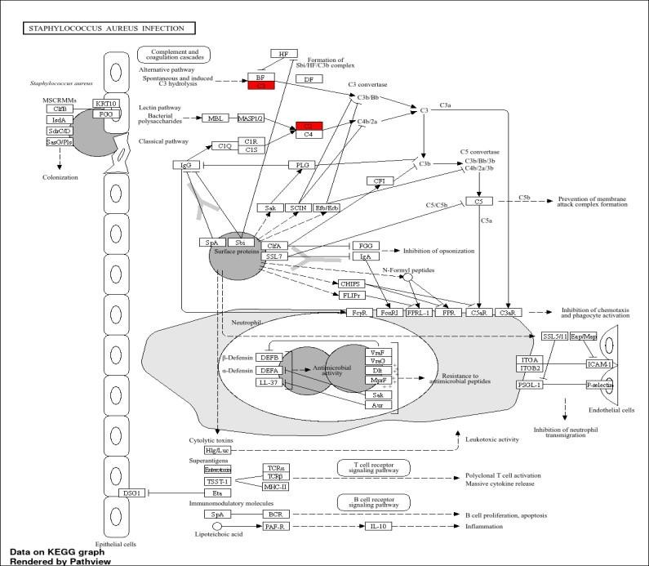

Hsa05133 Pertussis
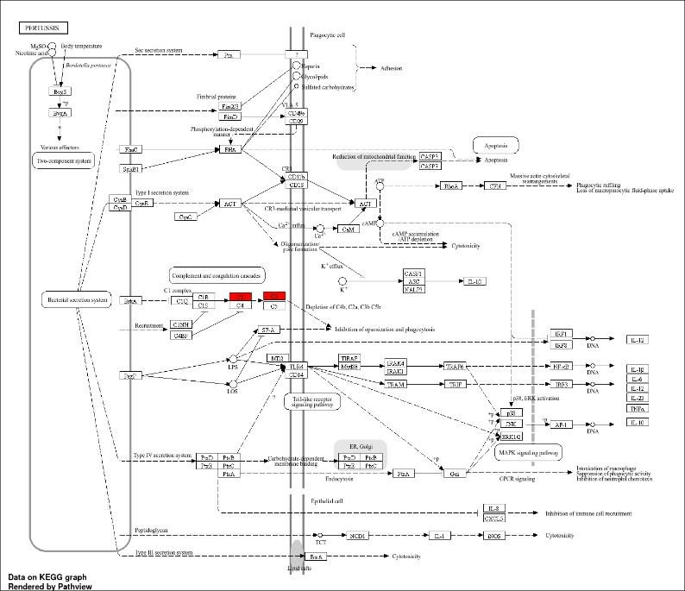

Hsa05171 Coronavirus disease-COVID-13
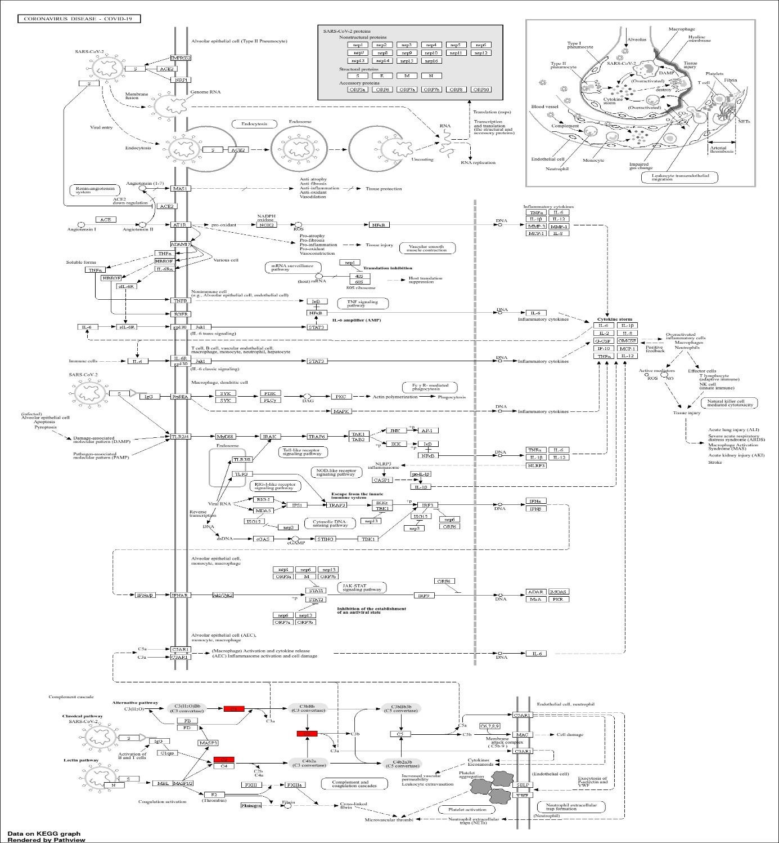
Figure 10: Significant new information about the roles of genes C3, C2, F5, F12, F8, and MT- ND5 in a variety of biological pathways is revealed by the enrichment analysis. These pathways are especially linked to immune responses, inflammation, and mitochondrial dysfunction, all of which are important contributors to neurodegenerative diseases like Parkinson's and Alzheimer's.

With a fold enrichment of 112.2 and an exceptionally low FDR of 1.4E-08, the Complement and Coagulation Cascades route (Path: hsa04610) shows a highly significant overrepresentation of your gene set. Important for immunological responses, especially inflammation and pathogen defense, this pathway is facilitated by the genes C3, C2, F5, F12, and F8. These genes may be involved in inflammatory processes that are prevalent in Alzheimer's and other neuroinflammatory illnesses, as evidenced by the involvement of complement proteins such as C3. With a fold enrichment of 50.2 and an FDR of 0.0102, the route Pertussis (Path: hsa05133) links C2 and C3 to the immunological response against the bacterial pathogen Bordetella pertussis. This correlation highlights complement activation's significance in immunological responses and pathogen protection, which may also be important in figuring out how immune failure fuels neurodegenerative illnesses. The notion that immune genes are essential for bacterial infection responses is further supported by the discovery that C2 and C3 are involved in the Staphylococcus aureus infection pathway (Path: hsa05150) (FDR = 0.0104, fold enrichment = 40.6). These results point to a wider role for complement system activation in neurodegenerative illnesses, where immunological dysregulation may worsen the course of the illness.
With a fold enrichment of 28.2 and an FDR of 0.0139, the route Systemic lupus erythematosus (Path: hsa05322) emphasizes the role of C2 and C3 in an autoimmune illness, in which the immune system targets its own tissues. Understanding the connection between complement proteins and autoimmune-driven neurodegeneration is essential to comprehending the potential role of these genes in neuroinflammatory diseases such as Alzheimer's.
The involvement of C2 and C3 (FDR = 0.0139, fold enrichment = 27) in the context of Alcoholic liver disease (Path: hsa04936) raises the possibility that chronic inflammation linked to complement activation in the liver may have similarities in the brain, contributing to neurodegenerative diseases like Alzheimer's, where inflammatory processes are also implicated in pathology.
With a fold enrichment of 16.4 and an FDR of 0.0305, the route Coronavirus illness - COVID-19 (Path: hsa05171) links C2 and C3 to immunological responses to the viral infection. Given the current COVID-19 pandemic, this route is especially pertinent since it illustrates how viral infections may worsen neurodegenerative illnesses, potentially by activating the immune system through complement proteins.

A number of other pathways with FDR values higher than 0.05 also offer important information on the role of genes in different illnesses. With an FDR of 0.1222 and a fold enrichment of 33.45, Legionellosis (Path: hsa05134) relates mitochondrial dysfunction in Legionella infections to the mitochondrial gene ND5, indicating that mitochondrial defects may be a common factor between neurodegeneration and infectious disorders. Although it is not directly linked to neurodegeneration, the Leishmaniasis route (Path: hsa05140, FDR = 0.1419, fold enrichment = 25.1) contains ND5 and points to a larger role for mitochondrial dysfunction in chronic disorders. Nonetheless, this highlights how crucial mitochondrial function is in several clinical circumstances. Given that mitochondrial dysfunction is a recognized feature of both Parkinson's and Alzheimer's diseases, ND5's participation in the Parkinson disease (Path: hsa05012) pathway (FDR = 0.1769, fold enrichment = 7.17) is especially noteworthy for neurodegenerative disorders. Given that ND5 is essential for the synthesis of energy in neurons, our discovery highlights the part mitochondrial dysfunctions play in neurodegeneration. Lastly, the Huntington disease route (Path: hsa05016) further supports this by highlighting mitochondrial involvement via ND5, which has an FDR of 0.1881 and a fold enrichment of 6.23.

Discussion

Genetic Intersection and Implications
Critical common genetic actors, such as C3, C2, ND5, F5, F12, and F8, which are implicated in inflammation, immunological regulation, mitochondrial dysfunction, and coagulation, are shown by the overlap of differentially expressed genes (DEGs) between SARS-CoV-2 and AD. Crucial elements of the complement system, C3 and C2 mediate immunological and inflammatory responses. In AD, they contribute to neuroinflammation and synaptic loss, while in SARS-CoV-2, their overactivation can cause cytokine storms. Both illnesses share oxidative stress and energy deficiencies, which are exacerbated by mitochondrial malfunction, as shown by the mitochondrial gene ND5. In the meanwhile, coagulation-regulating genes F5, F12, and F8 point to a common pathophysiology of vascular dysfunction and thrombotic consequences. All of these genetic crossings point to

a potential mechanism by which increased oxidative and inflammatory responses caused by SARS-CoV-2 infection might hasten neurodegenerative processes.

Pathway Enrichment Insights

The Kyoto Encyclopedia of Genes and Genomes (KEGG) pathway study reveals that important genes in AD and SARS-CoV-2 play similar functions. One example of how dysregulated immune responses lead to systemic and neural damage is the Complement and Coagulation Cascades (hsa04610) pathway, which is substantially enriched in both situations. A key component of the pathways linked to Huntington's, Parkinson's, and Alzheimer's diseases that connect systemic viral infections to neurodegenerative processes is mitochondrial dysfunction, which is fueled by genes such as ND5.
Furthermore, C2 and C3 are essential for bridging the molecular interactions between these disorders, and the Coronavirus Disease Pathway (hsa05171) highlights the impact of viral-mediated immune activation on neuroinflammatory pathways.

5.3 Relevance to Other Neurodegenerative Diseases
Although this study primarily focuses on Alzheimer’s disease, the identified genes and enriched pathways have broader implications across multiple neurodegenerative disorders. Several of the pathways highlighted in this analysis, including mitochondrial dysfunction, immune dysregulation, and complement activation, are well-established contributors to the pathogenesis of Parkinson’s disease, Huntington’s disease, and other neurodegenerative conditions.
Mitochondrial genes such as MT-ND5 are strongly associated with neurodegenerative diseases characterized by impaired energy metabolism and increased oxidative stress, including Parkinson’s and Huntington’s diseases. KEGG pathway enrichment further supports this association by highlighting mitochondrial involvement in neurodegeneration-related pathways.
Similarly, complement system components C2 and C3 have been implicated in neuroinflammatory processes beyond Alzheimer’s disease. Excessive complement activation has been shown to contribute to synaptic pruning, neuronal loss, and chronic inflammation in Parkinson’s disease, Lewy body dementia, and frontotemporal dementia.
Additionally, coagulation-related genes such as F5, F12, and F8 are increasingly recognized for their roles in neurovascular dysfunction, a shared pathological feature across many neurodegenerative disorders. These findings suggest that the molecular mechanisms identified in this study may represent common pathways underlying neurodegeneration rather than disease-specific processes

5.4Therapeutic Implications

Promising therapeutic targets for treating Alzheimer's disease (AD) and SARS-CoV-2 are presented by the discovered genetic and route overlaps. Inhibitors of C3 activation are one kind of immune regulation that targets the complement system and may help reduce inflammation and neuronal damage. Oxidative stress, a major contributor to neurodegenerative processes, may be decreased by improving mitochondrial function using tactics such antioxidants that target ND5. Additionally, the vascular problems linked to both disorders may be lessened by coagulation management with anticoagulants or medicines that modify F5, F12, and F8. However, in order to address the systemic consequences of SARS-CoV-2 and the chronic development of AD, these therapies call for precisely customized methods.

5.4 Future Research Directions
This study emphasizes the value of doing research in a variety of ways. In order to track cognitive decline and biomarkers that indicate the course of Alzheimer's disease (AD) in post-COVID-19 patients, longitudinal studies are crucial. Confirming the roles of important genes, including C3, C2, ND5, and coagulation factors, in the common pathophysiological pathways of these disorders requires molecular confirmation through experimental research. Furthermore, investigating medication repurposing possibilities for already available anti-inflammatory and mitochondrial-enhancing treatments may offer efficient dual-targeting approaches for AD and SARS-CoV-2.
Phase II: Prion Disease and Non-coding RNA Association
A second phase of this research will focus on exploring the potential link between SARS-CoV-2 infection, prion diseases, and non-coding RNAs (ncRNAs). Prion diseases are characterized by protein misfolding, neurodegeneration, and progressive neuronal loss, processes that share mechanistic similarities with other neurodegenerative disorders.
Emerging evidence suggests that viral infections may influence prion-like protein aggregation and propagation through inflammatory and immune-mediated pathways. SARS-CoV-2–induced immune activation and oxidative stress may contribute to conditions that favor protein misfolding and aggregation, potentially linking viral infection to prion-related neurodegenerative mechanisms.
Non-coding RNAs, including microRNAs and long non-coding RNAs, play crucial regulatory roles in gene expression, immune responses, and neurodegenerative disease progression. Recent studies indicate that ncRNAs may regulate prion protein expression, aggregation, and clearance, as well as modulate inflammatory signaling pathways involved in neurodegeneration.
Future work will investigate the regulatory roles of non-coding RNAs in prion-associated pathways and assess whether SARS-CoV-2–related immune activation influences ncRNA-mediated gene regulation. Integrating transcriptomic, epigenetic, and regulatory RNA analyses will provide deeper insights into the molecular interplay between viral infection, prion diseases, and neurodegenerative disorders.

Conclusion
This work highlights important pathways and genes that connect SARS-CoV-2 and Alzheimer's disease (AD), offering important new insights into the common molecular and genetic foundations of the two illnesses. The discovery of genes that overlap, such as C3, C2, ND5, F5, F12, and F8, emphasizes how crucial coagulation, immunological dysregulation, inflammation, and mitochondrial dysfunction are to the development of both illnesses. The participation of mitochondrial pathways, complement and coagulation cascades, and viral immune activation as key mechanisms connecting systemic viral infections to neurodegenerative processes was further confirmed by KEGG pathway analysis. The findings of this study suggest possible treatment options, including altering coagulation pathways to lessen vascular problems, improving mitochondrial function to address oxidative stress, and modifying the complement system to minimize neuroinflammation. To balance the long-term development of AD with the acute systemic effects of SARS-CoV-2, these treatment approaches need to be used carefully.

This study highlights the critical need for more research while also advancing our knowledge of the intricate relationship between viral infections and neurodegeneration. Effective therapies might be developed more quickly through longitudinal research, experimental confirmation of important genes, and repurposing of current medications. By

identifying the molecular similarities between these two illnesses, this research establishes the groundwork for novel treatment approaches to counteract their combined effects on the world's health.

References
- F. Alharbi et al., "A potential role of the spike protein in neurodegenerative diseases: A narrative review," Cureus, vol. 15, no. 1, p. e129846, Jan. 2023. Available: https://www.cureus.com/articles/129846-a-potential-role-of-the-spike-protein-in- neurodegenerative-diseases-a-narrative-review#!/
- J. Chen et al., "Multi-omic analysis of Alzheimer’s disease progression reveals novel therapeutic targets," Nature Scientific Reports, vol. 13, no. 1, pp. 1–12, 2023. Available: https://doi.org/10.1038/s41598-023-29778-4
- M. Cui et al., "Integrated transcriptomic and proteomic analysis uncovers regulatory mechanisms in cancer metastasis," Frontiers in Medicine, vol. 10, Article 1151046, 2023. Available: https://doi.org/10.3389/fmed.2023.1151046
- National Center for Biotechnology Information, "GSE171110: Transcriptome data of human immune cells under different conditions," GEO Accession Viewer. Available: https://www.ncbi.nlm.nih.gov/geo/query/acc.cgi?acc=GSE171110
- National Center for Biotechnology Information, "GSE53480: Differential gene expression in various cancer types," GEO Accession Viewer. Available: https://www.ncbi.nlm.nih.gov/geo/geo2r/?acc=GSE53480
- PubMed Central, "The impact of spike protein on neurological pathogenesis," PMC, Article PMC10002862. Available: https://www.ncbi.nlm.nih.gov/pmc/articles/PMC10002862/

